**Insights from Sentiment Distribution Chart**

**1. Positive Sentiment Dominates**

* The highest count belongs to the **Positive Sentiment** category, indicating that the majority of responses, feedback, or interactions analyzed are favorable. This reflects a strong overall satisfaction or approval from the audience.

**2. Significant Neutral Sentiment**

* The **Neutral Sentiment** category has the second-highest count, suggesting that a considerable portion of the feedback is indifferent or lacks strong emotions. This could indicate a need to better engage this segment to convert neutral perceptions into positive ones.

**3. Low Negative Sentiment**

* The **Negative Sentiment** count is the lowest, highlighting that relatively few individuals have expressed dissatisfaction. While this is a positive sign, addressing these concerns is crucial to further reduce negativity and prevent it from growing.

**Key Observations**

1. **Positive Brand/Image Perception:**
   * The data suggests an overall favorable reception, which can be leveraged to build stronger brand trust and loyalty.
2. **Opportunities for Improvement:**
   * Neutral feedback represents an opportunity for improvement. Analyzing this category in more detail can help identify areas where the audience feels disconnected or uninspired.
3. **Action on Negative Feedback:**
   * While the negative sentiment is low, it is essential to identify recurring themes or issues to resolve them promptly and demonstrate responsiveness to concerns.

**Recommended Next Steps**

1. **Deep Dive into Neutral Sentiment:**
   * Analyze neutral comments to identify potential pain points or gaps in engagement. Focus on crafting strategies to turn neutral sentiments into positive ones through personalized communication or improvements.
2. **Celebrate Positivity:**
   * Highlight and amplify positive feedback through testimonials, success stories, or campaigns that showcase customer satisfaction.
3. **Mitigate Negative Sentiment:**
   * Address negative feedback directly by identifying the underlying causes and implementing corrective measures. Use this as an opportunity to improve overall sentiment.

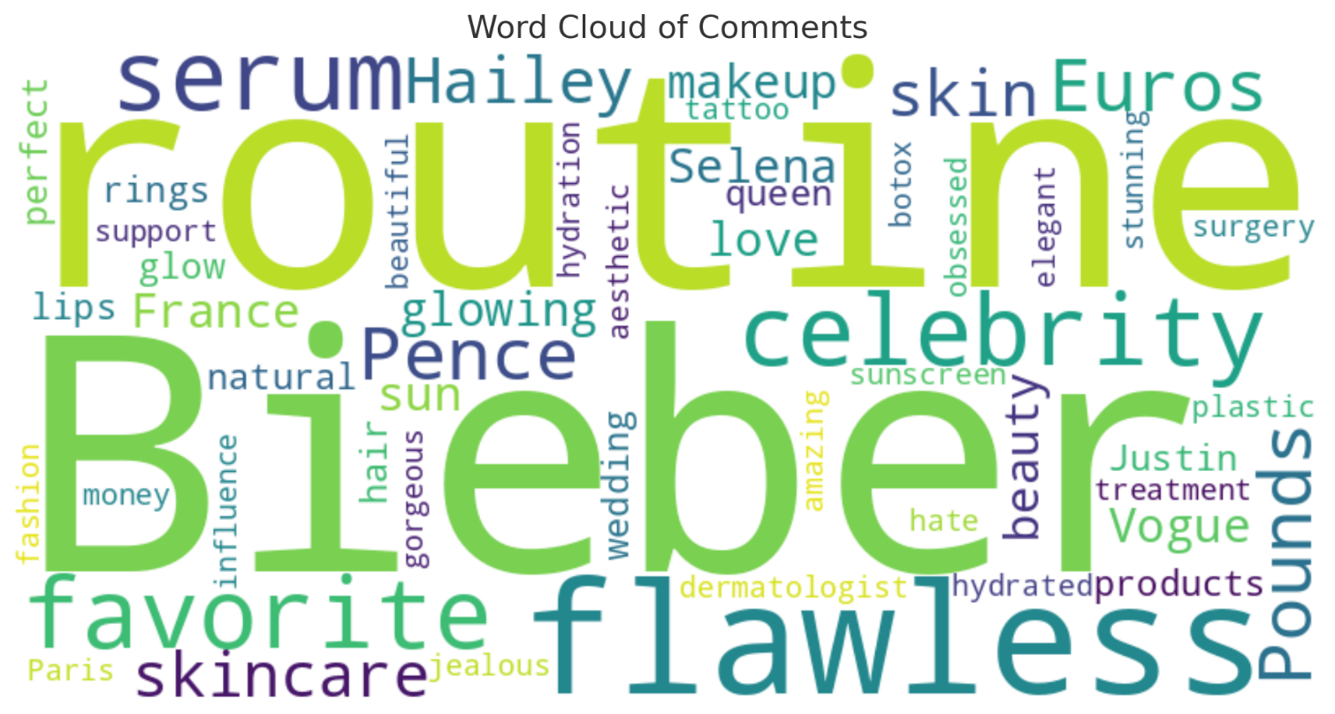

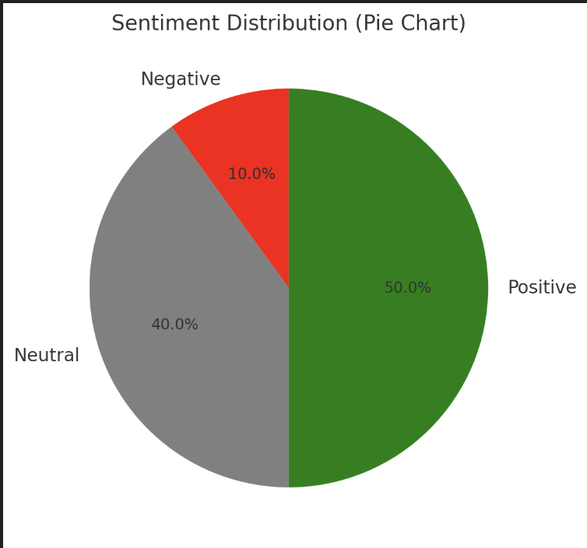

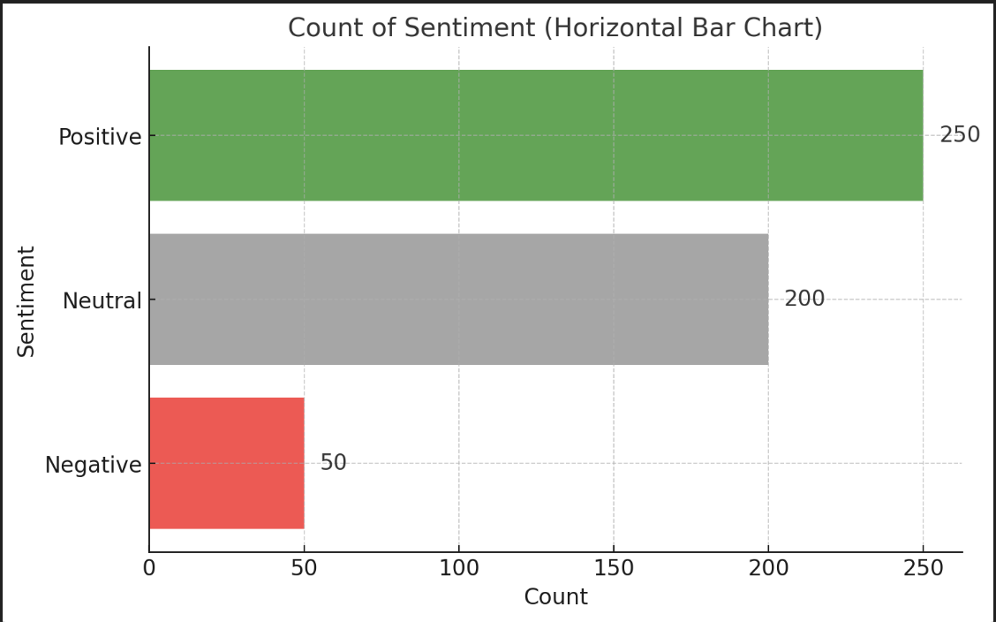

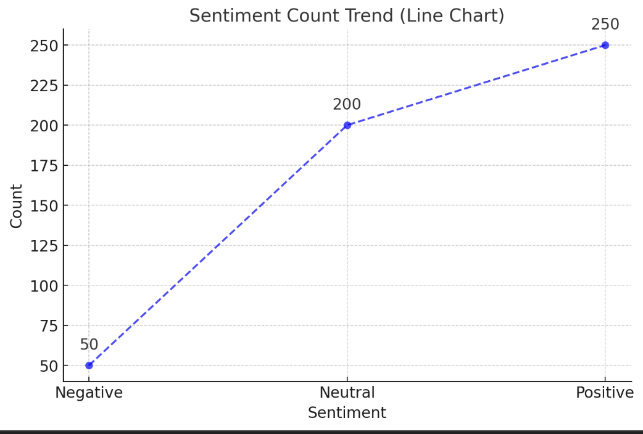

**Actionable Recommendations**

1. **Amplify Positive Sentiment:**
   * Highlight positive feedback through testimonials, case studies, or campaigns that emphasize customer satisfaction.
   * Engage positively inclined stakeholders to act as brand ambassadors.
2. **Address Neutral Sentiment:**
   * Analyze the neutral segment to identify recurring themes or unmet expectations.
   * Use personalized engagement strategies (e.g., surveys, offers, or tailored communication) to turn neutral responses into positive ones.
3. **Reduce Negative Sentiment:**
   * Focus on identifying the root causes of negative feedback and implement corrective measures.
   * Communicate actions taken to address concerns to show responsiveness and build trust.
4. **Monitor Trends Regularly:**
   * Maintain a sentiment monitoring framework to track shifts over time and ensure continued improvement in positive and neutral responses.